3 Boys Poker Parties - Cancellation Policy
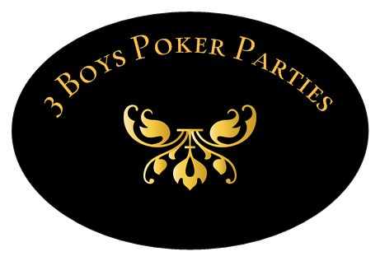

Cancellations Made:

3 Days (72 Hours or Less) Prior to Event Date – 100% of deposit forfeited.
4-7 Days Prior to Event Date – 75% of deposit forfeited.
8-14 Days Prior to Event Date – 50% of deposit forfeited.
15 or More Days Prior to Event Date – 25% of deposit forfeited.

- Please note that cancellation fees are calculated based on the date we receive your signed Cancellation Request Form. All Cancellation Request Forms must be sent to info@3boyspokerparties.com.

- Verbally speaking with our customer service representatives without filling out a request form will not guarantee that your cancellation has been processed or acknowledged. We will NOT accept email cancellations unless they have a complete, signed, and attached Cancellation Request Form. A copy of the Cancellation Request Form can be found on www.3boyspokerparties.com.

- Customers may also email a scanned/digital Cancellation Request Form with your electronic signature.

Orders Not Fully Paid For:

- Within 3 Days (72 Hours) or Less Prior to Event – 100% of deposit forfeited.
Amendment Fees:

- Any amendments made to a reservation within two weeks of an event date will incur a minimum $30.00 Amendment Fee (per change). The following constitute an amendment to an event:
- Change in event date
- Any change resulting in a reduction in equipment order
- Cancellation of any add-on service (bartender, waitstaff, DJ, etc.)

